**Steps for the apache https setup:-**

* Copy apache2 and php files from production to staging server if it is not already copied using SCP command.

**Syntax:**

*scp filename username@server:Destination path*

**Eg:**

scp apache2.zip tibco@10.4.124.222:/opt/tibco/

scp php5.zip [tibco@10.4.124.222:/opt/tibco/](mailto:tibco@10.4.124.222:/opt/tibco/)

* Create or Copy (if already existing) a .crt and .key file under certs directory.

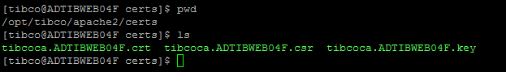

* Specify the key and certs path in http-gateway-ssl.conf

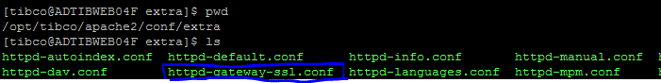

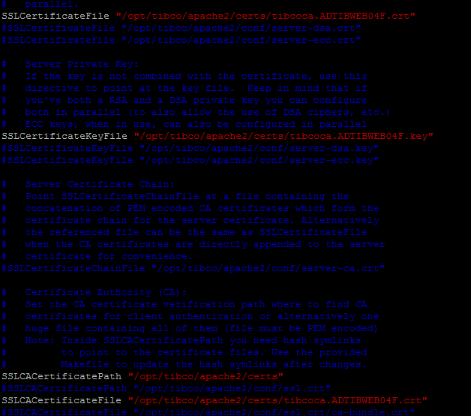

* Include httpd-gateway-ssl.conf file in httpd-gateway.conf

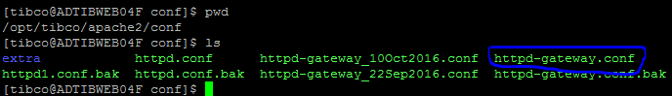

Add the below line in httpd-gatway.conf:-

*Include conf/extra/httpd-gateway-ssl.conf*

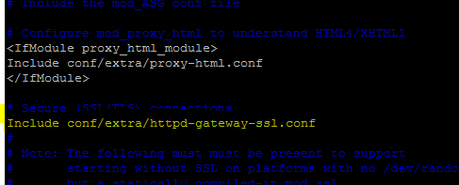

* Uncomment the Load module for mod_ssl.so in httpd-gateway.conf

*LoadModule ssl_module modules/mod_ssl.so*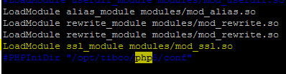

* Add/Edit the proxy pass if required for particular API in httpd-gateway.conf

Eg:

*ProxyPass /fs/v1/services/gpp* [*http://ADTIBWEB04F.privatecloud.local:3222/fs/v1/services/gpp*](http://ADTIBWEB04F.privatecloud.local:3222/fs/v1/services/gpp)

* Make sure RV_Home is set for the apache server. If not then please run below three commands

*export RV_HOME=/opt/tibco/tibrv/8.4*

*export PATH=$RV_HOME/bin:$PATH*

*export LD_LIBRARY_PATH=$RV_HOME/lib:$RV_HOME/lib/64:$LD_LIBRARY_PATH*

* Start apache httpd with configuration file and check the nohup.out log.

*nohup /opt/tibco/apache2/bin/httpd -f /opt/tibco/apache2/conf/httpd-gateway.conf -k start 2>&1 &*

* Below screen will appear upon successful start of apache.

